Title: | Window Lifter  Window Lifter Design V 1.2

History
Issue status  (Index) | Maturity/Date  (draft/invalid/valid)  (dd-mmm-yyyy) | Author  CES | Check/Release  CES | Description
1.0 | Draft  25-Jun-15 | Gilberto Ochoa | Gilberto Ochoa | Window Lifter Design
1.1 | 02-Jul-15 | Gilberto Ochoa | Gilberto Ochoa | It is renamed one case of the State Machine
1.2 | 03-Jul-15 | Gilberto Ochoa | Gilberto Ochoa | Elimination some function and become in Macros

Table of Contents
1 Purpose 3
2 Definitions and abbreviations 3
3 Realization constraints and targets 3
4 SW Conceptual design 3
5 SW Component internal breakdown 4
5.1 Function void Evaluate_bounce_button (void) 5
5.2 Function void State_Machine (void) 5

Purpose
Simulating movement of the window. The movement of the window has to be simulated turning on/off the LEDS creating the animation of the window movement.

Definitions and abbreviations
Definitions
Window Lifter | The module to control the window (UP and DOWN) and has a feature named anti-pinch.
Anti-pinch | Detected accidents between window and some human body parts.

Abbreviations

GPIO General Purpose Input / Output
PIT Periodic Interrupt Timer
References
N° | Document name | Reference
1 | Window lifter requirements

Realization constraints and targets
- This module control the movement of the window (UP and DOWN) through two buttons.
- If the button is pressed more than 10 milliseconds is considered a valid button.
- To select between automatic o manual.
Manual: Pressed the button more than 500 milliseconds.
Automatic: Pressed the button between 11 and 500 milliseconds.
- The movement of the window has to be simulated turning on/off the LEDS creating the animation of the animation of the window movement.
- The time between each transition shall be 400 milliseconds.
- When the window is going up should turn on a LED color blue.
- When the window is down should turn on a LED color green.
- Anti-pinch only must response when the window is UP automatic or manual.
- If this signal is valid then the module has to open the UP Movement and then DOWN the window until the window get totally open.
- After window is totally open the module has to ignore during 5 seconds all button press.
- After this time the module has to recognize every button press.

Assumption
- If the window is moving can be stopped if the opposite button is pressed
For example: The window is down, if you want to stop, you have to press the Button to UP and window will stop.
- If the window is in automatic mode must be able to pass to manual state or vice versa.

SW Conceptual design
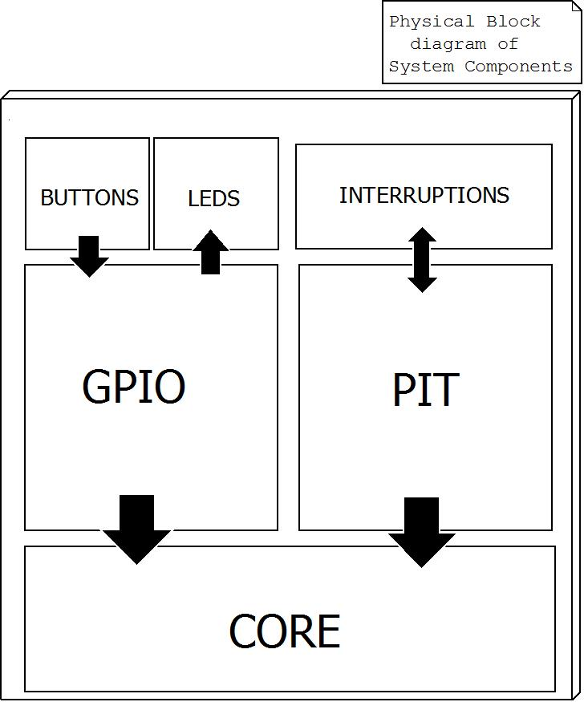

SW Component internal breakdown
In the design of window lifter has been subdivided in different functions and different files.

File GPIO: Configure the different register to use buttons and LEDS.

File button: Check if the button (UP and DOWN) if pressed for more than 10 milliseconds to consider a validate button press. If the button is considered a validate button press then the next step is evaluate the time button pressed to select automatic or manual movement.

File Window lifter: This file contains the state machine that control the flow of the program, depending on the state of the button that return is where the State Machine will continue.
This file also evaluate the feature anti-pinch only when the movement is UP (Automatic or manual).

Function void Evaluate_bounce_button (void)

Description | Function that evaluate if the button is pressed for more than 10 milliseconds and select automatic or manual
Parameter 1 | void
Return Value | void
Precondition | This function will call when an interruption occurs
Post condition
Error Conditions

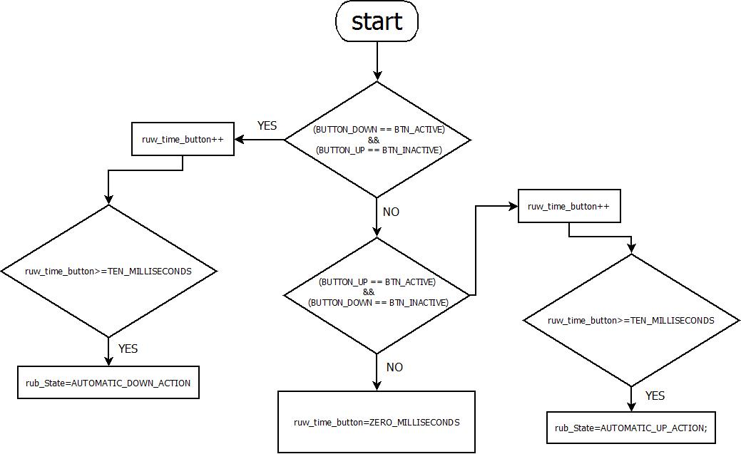

Function void State_Machine (void)
Description | This function is called every millisecond and contains the State machine that control all program.
Parameter 1 | void
Return Value | void
Precondition
Post condition
Error Conditions

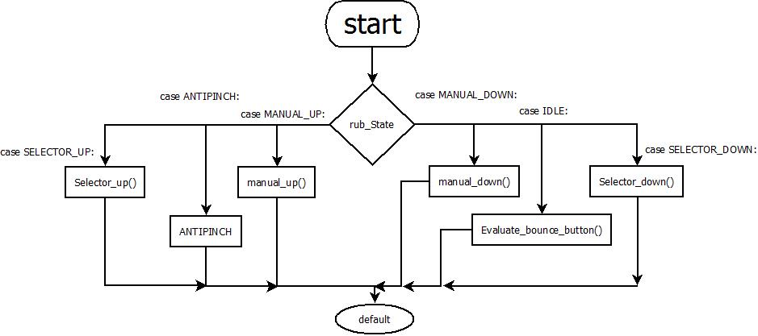

Function void window_down (void)
Description | This function controls the movement down of the window
Parameter 1 | void
Return Value | void
Precondition
Post condition
Error Conditions

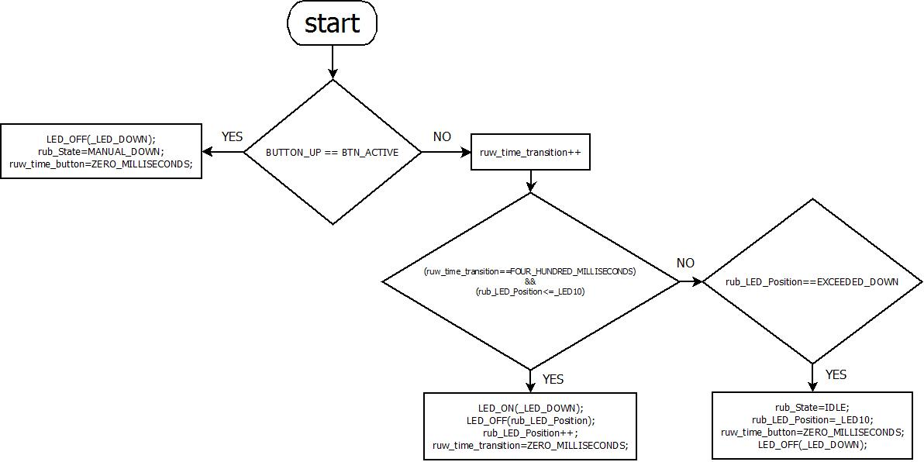

Function void window_up (void)
Description | This function controls the movement up of the window
Parameter 1 | void
Return Value | void
Precondition
Post condition
Error Conditions

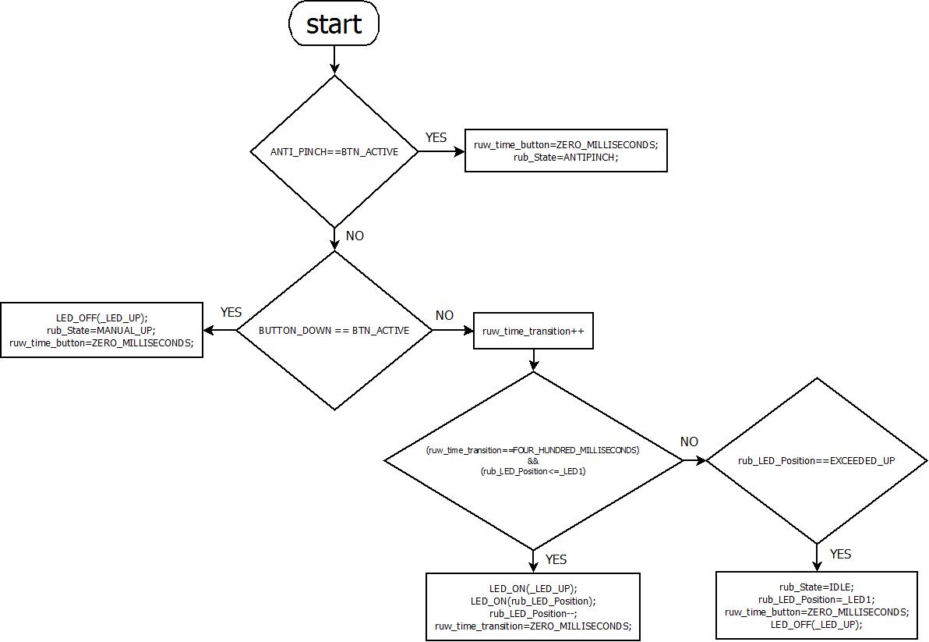

Function void manual_up (void)
Description | This function evaluate if the BUTTON_UP is pressed to continue UP
Parameter 1 | void
Return Value | void
Precondition
Post condition
Error Conditions

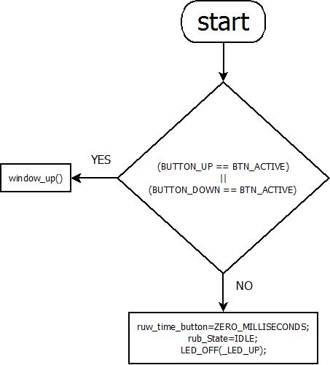

Function void manual_down (void)
Description | This function evaluate if the BUTTON_DOWN is pressed to continue DOWN
Parameter 1 | void
Return Value | void
Precondition
Post condition
Error Conditions

